Note: Association rules based on transaction matrix

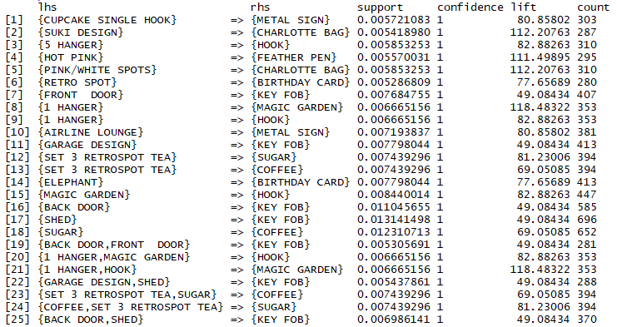

For a selected product,

